Experiment 3: Detect Image Outlines Using Canny
Aim: To detect the edges and outlines of an image using the Canny edge detection function in OpenCV.
Procedure:
- Read the input image.
- Convert the image into grayscale.
- Apply Canny edge detection using suitable threshold values.
- Display the original image and detected edges.
- Close the display windows.
Program:
import cv2
img = cv2.imread(r"D:\Amrita\Pictures\Screenshots\image.png")
gray = cv2.cvtColor(img, cv2.COLOR_BGR2GRAY)
edges = cv2.Canny(gray, 100, 200)
cv2.imshow("Original Image", img)
cv2.imshow("Image Outline", edges)
cv2.waitKey(0)
cv2.destroyAllWindows()
Input:

Output:
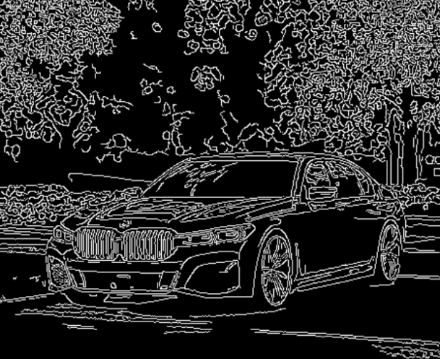
Result:
The edges and outlines of the input image were successfully detected using the Canny function.

